Wiseburg UMC
Breakfast Buffet
November 5, 2016
$8.00 per person
Sit-Down from 7:30 to 10:30 a.m.
All you can eat!
Featuring: scrambled eggs, bacon, ham, pancakes, chipped beef gravy, sausage, biscuits, coffee, juice and fruit salad.

Located ½ mile east of York Rd.
(rt 45) on Wiseburg Road
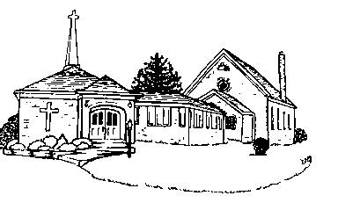
Breakfast is served in the hall at the top of the hill (same place as the Chicken Dinners).

